CONTENTS IN BRIEF

Detection of acute phase response proteins by semi-quantitative latex agglutination test 1

Counter Immunoelectrophoresis 4

Detection of Anti-nuclear antibodies (ANA) by Indirect Immunofluorescence 5

Detection of soluble antigen by sandwich ELISA 8

Preparation of cell suspensions from spleen 9

Flow cytometry 11

Detection of acute phase response proteins by semi-quantitative latex agglutination test

PRINCIPLE
The latex agglutination test is a laboratory method to check for certain antibodies or antigens in a variety of bodily fluids including blood, urine, saliva, or cerebrospinal fluid.
During the acute tissue injury period induced by trauma, bacterial infection and infarction, some of acute phase plasma protein synthesized by liver is significantly increased. These proteins were called acute phase response proteins, and they were injury- or inflammation-induced serum glycoprotein. Among them, C-reactive protein (CRP) is the first discovered. When the body under the acute inflammatory phase such as bacterial infection, secondary infection, period of acute inflammation of rheumatic fever, acute myocardial infarction (AMI), or acute rejection in organ transplantation, and so on, the CRP is significantly increased, and usually reaches peak at 48 hours after inflammation.
In this assay, the principle of indirect agglutination test was applied. Mix the serum samples with the latex beads which sensitized with the anti-CRP serum. If the samples contain a sufficient amount of CRP, agglutination of latex particles can occur. With different dilutions of serum samples tested, through different degrees of positive reaction, the semi-quantitative purposes can be achieved.

MATERIALS
1. Serum samples for inspection (has been diluted 1:3 and inactivated)
2. CRP latex reagent
3. Reaction slide
4. 50μl pipette

PROCEDURE
1. On the reaction slide, add a drop of diluted serum samples 50μl, and then add a drop of buffer solution, then shake uniform.
2. Add a drop of CRP latex reagent, gently shake for 5 minutes.
3. See the results.
RESULTS
1. Those who have a clear visual observation of agglutination can be judged positive, which means that serum CRP concentration of the samples was higher than 10μg/ml.
2. Positive serum samples can be further diluted and repeat the above method, go on with semi-quantitative test, the maximum dilution of serum which can occur agglutination reaction is the titer of serum CRP.

NOTES
1. Latex reagent can not be frozen, it should be kept in the refrigerator with 2-8℃. Before use it should be returned to room temperature and shake uniform. If room temperature is less than 20℃, the shaking time should be extended for 2 minutes more after mixed with the latex reagent.
2. Rheumatoid factor can interfere with this experiment and produce false positive results. So the serum samples should be pretreatment to destruction of rheumatoid factor if the patient with rheumatic diseases wanted to use this experiment to determine whether their disease was active.
3. Normal value ranges may vary slightly among different laboratories.

（HaiFeng Gao）

Counter Immunoelectrophoresis

PRINCIPLE
Counter Immunoelectrophoresis (CIEP) is a variation of double immunodiffusion, in which antigen and antibody are forced to move toward each other with an electric current (antibodies move to the cathode while most antigens are strongly negatively charged and move toward the anode). Precipitin lines can be visualized between the antigen and antibody wells. The method is faster and more sensitive than double immunodiffusion. Visible precipitation can be usually observed after 30-45 mins in CIEP, and the sensitivity is increased by 10-20-fold compared with double immunodiffusion.

MATERIALS
1. Sample (antigen)
2. Antibody
3. PBS (0.05M phosphate, buffered saline solution, 0.05 M, pH 7.2)
4. Agarose
5. Barbiturate buffer (pH 8.6)
6. Electrophoresis System , pipette etc

PROCEDURE
1. Wells with a diameter of 3 mm are prepared in 1.5% agarose gel (6mm apart).
2. Ten microlitres of antigen (sample) and the same volume of the antibody are applied into the wells on the anode and the cathode sides, respectively.
3. Protein migration is proceeded under the condition of 3～4mA/cm for 30-45 mins.

RESULTS
If the antigen and antibody are specific for each other, they combine and form a distinct precipitin line.

NOTES
1. To avoid the denaturation of proteins, the electric current should not be too high.
2. Electrode should be put in correct direction.
3. The concentration of antigen and antibody should be appropriated.
4. The time required for electropheresis is closely related to the distance between wells.

(Bo Gao)

Detection of Anti-nuclear antibodies (ANA) by Indirect Immunofluorescence

PRINCIPLE
Serum anti-nuclear antibodies (ANA) bind to the corresponding antigens (Hep-2) present in rat liver sections. The antigen-antibody complexes are detected by means of a fluorescein labeled anti-human immunoglobulin, and visualized with the aid of a fluorescence microscope.

MATERIALS
1. Slides covered with Hep-2 cells
2. PBS-Tween (10 x, pH 7.2)
3. Positve Control serum
4. Negative Control serum
5. FITC-labeled anti-human IgG
6. Test patient serum
7. Moist chamber
8. Wash tray
9. Coverslips
10. Fluorescence microscope

PROCEDURE
1. Bring the reagents and samples to room temperature.
2. Place 1 drop (50μL) of the diluted sample or Control on each slide (A) well, making sure that it is completely covered (Note 1).
3. Incubate the slide for 30 minutes at room temperature (15-30ºC) into a moist chamber.
4. Drain sample drops off by gently tapping the inclinated slide. Avoid cross-contamination of the sera.
5. Rinse gently the slide with PBS (see Reagent Preparation) (Note 2).
6. Wash thoroughly the slide by immersing in a washing tray filled with PBS for 5 minutes. Change PBS and repeat wash.
7. Carefully dry off the slides by using the blotting paper provided. Keep the tissue section moist along the procedure.
8. Place 1 drop of Reagent second antibody on each well. Incubate the slide for 30 minutes at room temperature (15-30ºC) into a moist chamber.
9. Wash (step 6) and dry (step 7).

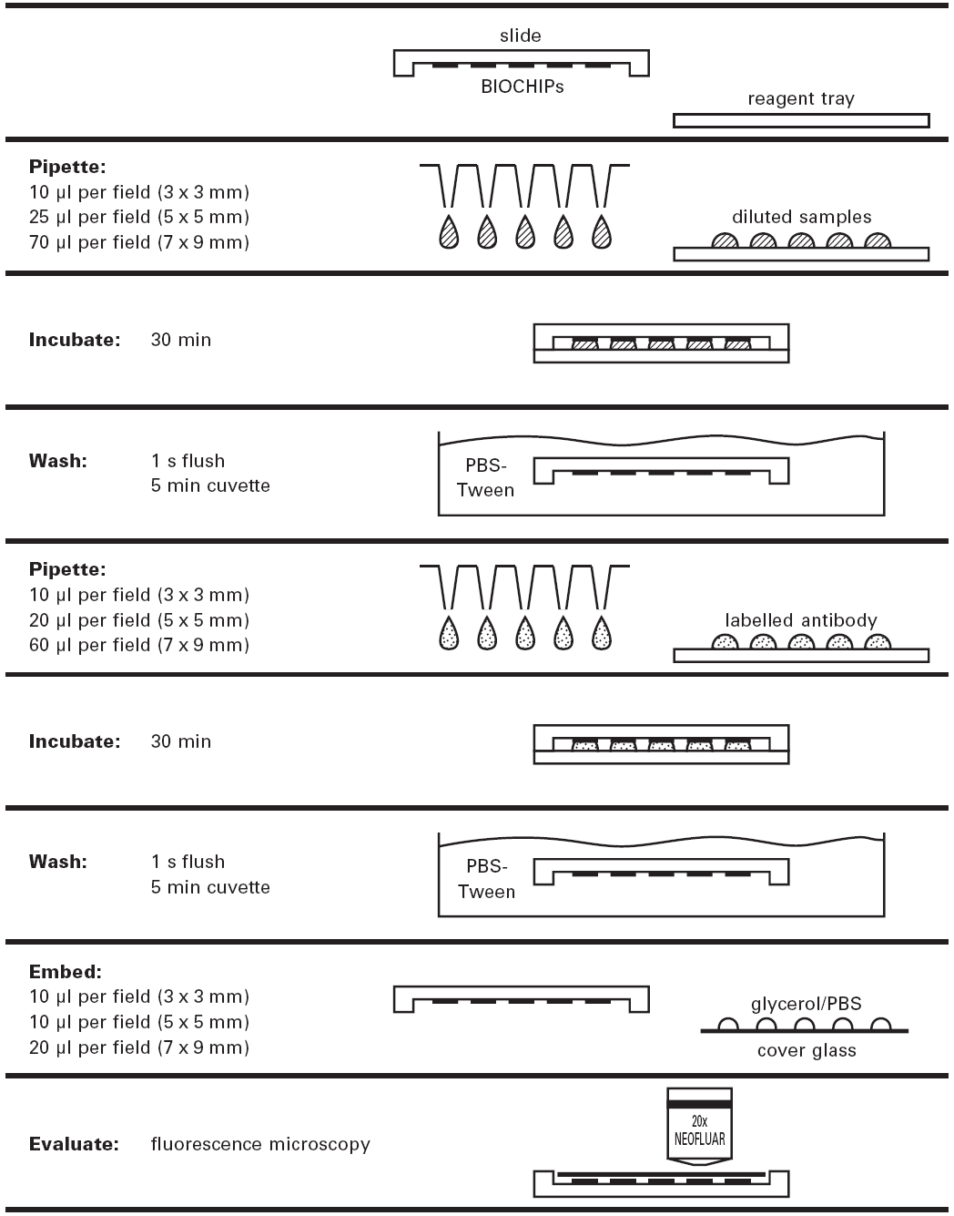
10. Place several drops of PBS on the slide and cover with a coverslip avoiding the formation of air bubbles.

RESULTS
Examine the slide using the fluorescence microscope (250-400x). For best results, the slides should be read immediately. Select reading fields in the inner part of the tissue section. Fluorescent intensity in the tissue edge is not representative of the slide preparation.
Observation of specific fluorescent staining, described as follows, should be considered as a positive result.
ANA: There are different nuclear fluorescent staining patterns that can coexist in the same serum. The pattern may be modified with the dilution of the serum. There are 4 main antinuclear patterns
Homogeneous: Homogeneous and uniform fluorescence throughout the nucleus of interphase cells. Strong fluorescence of mitotic cells.
Peripheral: Peripheral staining of the nuclei, more intense at the inner edge, and homogeneous staining of the rest of the nucleus.
Speckled: Speckles in the nucleus of the cell. Nucleoli are not stained. There is a variety of sizes and shapes of the speckles, depending on the reacting antigen.
Nucleolar: There are two major nucleolar patterns. a) Nucleolar staining with homogeneous pattern. Often it can be found together with a weak homogeneous fluorescent pattern in the cell nucleus. b) Speckled staining of the nucleoli in interphase cells. Punctuate staining of the nucleolar organizing regions of mitotic chromosomes.
Positive sera may be titered. The serum titre is defined as the highest dilution showing a positive result.
When none of the above specific stainings are observed, the result should be considered negative for these autoantibodies.

NOTES
1. Avoid touching the tissue section fixed into the wells along the procedure.
2. Use a squeeze bottle or a pipette to wash the slides, avoiding cross contamination among the adjacent samples.

（Xiaowu Hong）

Detection of soluble antigen by sandwich ELISA

PRINCIPLE
The assay is based on simultaneously binding of one antigen from samples to two antibodies, one immobilized on microtiter plates, and other conjugated the enzyme. After a washing step, chromogenic substrate is added and colour is developed. The enzymatic reaction (color) is proportional to the amount of antigen present in the sample. Add stop solution terminates the reaction.

MATERIALS
1．coating buffer-carbonate/bicarbonate buffer 0.1 M pH9.6
2．Washing solution (PBS-Tween or PBS-T)
PBS, 0.05M pH7.4 containing 0.05% (v/v) Tween-20
3．Dilution buffer-PBS-T containing 5% (v/v) FCS
4．Substrate (TMB) solution
5．Stopping solution (H2SO4) for TMB
6．ELISA plate reader with appropriate filter (450 nm for TMB)
7．ELISA plate，Micropipettes with disposable tips，Paper towels

PROCEDURE
- Coating plates with capture antibody- 100 μl per well at 4°C overnight.
- Washing plates-Fill the each well of plate with washing solution, shake out, bang to near dryness and repeat washing for at least twice more.
- Applying test samples- 100 μl per well, 37°C for 2h
- Washing plates as given above
- Applying the conjugate- 100 μl per well, 37°C for 2h
- Washing plates as given above
- Applying theTMB substrate solution, 100 μl per well, cover plates, RT for 15min
- Stopping the reaction, 50 μl per well. Blue color turns yellow.
- Reading the plates

RESULTS
- Qualitative test: The substrate solution color change (blue) are read by eye, turned brown are positive while colorless are negative.
- Quantitative test: the absorbance is measured on an ELISA reader with the appropriate filter setting. The concentration of the samples is then determined by comparing the O.D. of the samples to the standard curve.

NOTES
- Do not allow reagents to dry on the wells.
- Failure to wash the wells properly will lead to high backgrounds.

（Qing Lu）
Preparation of cell suspensions from spleen

PRINCIPLE
The removal of lymphoid organs for further culture, isolation of cell populations, or direct testing is one of the simplest and most frequently used procedures in immunology. Typical uses include providing cells for cytotoxicity or proliferation assays, for analysis of cytokine production or response, and for the isolation of T, B, and adherent cell subpopulations for culture or reconstitution of other animals.

MATERIALS
1. Mouse
2. 70% ethanol
3. PBS or PRMI-1640 incomplete medium
4. ACK lysing buffer
5. 0.4% Trypan blue
6. Scissors , forceps and 15ml conical tube
7. 5-ml syringe、Sterile petri dishes, 200-um mesh nylon screen
8. hemacytometer
9. Micro-pipette, micro-reaction plate
10. Centrifuge, Microscope

PROCEDURE
Removal the spleen
1. Sacrificed mouse and soak in 70% ethanol solution for 3-5 min.
2. Place it on its back on clean, dry, absorbent paper.
3. Make a midline incision with surgical scissors.
4. Make a 1-in. incision at the left side of the peritoneal wall with surgical scissors.
5. Gently pull the spleen free of the peritoneum, tearing the connective tissue behind the spleen.
6. Place the spleen in a petri dish containing several milliliters of PBS or tissue culture medium.
Preparation of cell suspension.
1. Wash the spleen with PBS buffer in petri dish.
2. Using the plunger end of the syringe, mash the spleen through the cell strainer into the petri dish.
3. Rinse the cell strainer with 5mL PBS. Discard the strainer.
5. Transfer the suspended cells to a 15mL conical tube.
6. Centrifuge cells at 1000 for10 minutes.
7. Discard supernatant and resuspend pellet in 5mL ACK lysis buffer to lyse the red blood cells. Incubate at RT for 5 minutes.
8. Add 5mL PBS and spin as before.
9. Discard supernatant and resuspend pellet in 3mL PBS, for next procedure (e.g., dead cell removal, cell counting, or fractionation).
The dye exclusion test
1. Transfer an aliquot of cell suspension to a test tube. Then mix 1 part of 0.4% trypan blue and 1 part cell suspension (dilution of cells). Allow mixture to incubate ~3 min at room temperature.
2. Apply a drop of the trypan blue/cell mixture (e.g., 10μL) to a hemacytometer. Place the hemacytometer on the stage of a binocular microscope and focus on the cells.
3. Count the unstained (viable) and stained (nonviable) cells separately in the hemacytometer.

RESULTS
total number of viable cells per ml of aliquot
total number of cells per ml of aliquot
Viable cells (%) =
× 100
Cells/ml =( average count/square) ×(dilution factor) ×10⁴
Total cells=(cells/ml) ×(the original volume)
NOTES
1. Prepare the splenocytes usually for the next step in experiment. So if need , must be strictly aseptic technique.
2. Using ACK lysing buffer, the incubation time should be proper in order to avoid damaging other cells.
3. If cells are exposed to Trypan Blue for extended periods of time, viable cells as well as non-viable cells, may begin to stain.

(XueYang)
Flow cytometry

PRINCIPLE
Flow cytometry employs instrumentation that scans single cells flowing past excitation sources in a liquid medium. The technology is unique in its ability to provide rapid, quantitative, multiparameter analyses on a single living (or dead) cells. It is a widely used method for analyzing the expression of cell surface and intracellular molecules (on a per cell basis) by their reaction with fluorochrome-labeled monoclonal antibodies and for using the signals so generated to separate cells of defined phenotype from heterogeneous populations.

MATERIALS
1. Animals: Kunming mice, weighing about 20-25 g
2. PBS with 1% FCS
3. ACK lysing buffer
4. Fluorochrome-labeled antibody (FITC or PE-labeled anti-CD3, anti-CD4, anti-CD8 antibody)
5. 100-μM nylon mesh
6. Sacrifice mice instruments (see Experiment 5)

PROCEDURE
1. Harvest cells from spleen, preparing a single cell suspension. Remove the red blood cells by lysis. Wash and resuspend cell pellet in cold PBS with 1% FCS to a concentration of 1×10⁷ cells/ml (i.e., 10⁶ cells per 100 µl) .
2. Add 1ul each fluorochrome-labeleded antibody or isotype control simultaneously for 1×10⁶ cells . Mix gently. Incubate 20 min at 4°C in dark.
3. Add 2ml PBS and centrifuge 5 min at 2000 rpm. Discard supernatant and repeat wash.
4. Resuspend stained cell pellets in 300ul PBS with 1% FCS. Keep cell suspension on ice until analyzed by flow cytometry.

RESULTS
NOTES
1. Perform strictly according to the instruction, especially adding the antibody.
2. Antibody and cell reaction should be mixed fully and gently.
3. Keep the cells cold and dark when adding the fluorescence antibody.

（Xue Yang）

